**INTRODUCTION**

**NAME:** KARTIKEYA NARIAN KHANNA

**BRANCH:** DEVOPS

**ROLL.NO:** R171219049

**SAP ID:** 500078285

**SEMESTER:** 3

**SUBJECT:**ADVANCED DATABASE MANAGEMENT SYSTEMS

**SUBMITTED TO:** Mr. Ankit Khare

**DATE OF SUBMISSION:** 3rd DEC,2020

**EXPERIMENT-1**

**Title:** To understand DDL and DML commands

**Objective:** To understand the concept of designing issue related to the database with creating, populating the tables. Also familiarize students with different ways of manipulation in database.

**1. Create the tables:**

**Table name:** CLIENT1

**Code:**

use lab_work;

CREATE TABLE CLIENT1 (

Colunmn_name varchar(10),

Name1 varchar(50),

ADDRESS1 varchar(30),

ADDRESS2 varchar(30),

CITY varchar(15),

PINCODE int,

STATE varchar(15),

BALDUE decimal(10,2)

);

**Table Name:** PRODUCT_MASTER

**Code:**

use lab_work;

CREATE TABLE PRODUCT_Master (

PRODUCTNO varchar(10),

DESCRIPTION1 varchar(50),

PROFITPERCENT decimal(4,2),

UNIT_MEASURE varchar(30),

QTYONHAND int,

REORDERL_VL int,

SELLPRICE decimaL (8,2),

COSTPRICE decimal(10,2)

);

**Table Name:** SALESMAN_MASTER

**Code:**

use lab_work;

CREATE TABLE SALESMAN_Master (

SALESMANNO varchar(10),

SALESMANName varchar(50),

ADDRESS1 varchar(30),

ADDRESS2 varchar(30),

CITY varchar(15),

PINCODE int,

STATE varchar(15)

);

**2. Insert the data into their respective tables:**

**CLIENT1**

**Code:**

use lab_work;

INSERT INTO CLIENT1

VALUES('C00001', 'Ivan bayross','ANDHERI ','EAST', 'Mumbai', 400054, 'Maharashtra', 15000),

('C00002', 'Mamta muzumdar', 'Shanthi Colony Main Road','AI Block','Madras', 780001, 'Tamil nadu', 0),

('C00003', 'Chhaya bankar','ANDHERI','WEST', 'Mumbai', 400057 ,'Maharashtra' ,5000),

('C00004', 'Ashwini joshi', 'Sarvepalli Radhakrishnan Rd','Soladevanahalli', 'Bangalore', 560001, 'Karnataka', 0),

('C00005', 'Hansel colaco', 'Goregaon', 'WEST', 'Mumbai', 400060, 'Maharashtra', 2000),

('C00006', 'Deepak sharma','Sturrock Rd','Attavar', 'Mangalore', 560050 ,'Karnataka', 0);

**PRODUCT_MASTER**

**Code:**

use lab_work;

INSERT INTO PRODUCT_Master

VALUES('P00001', 'T-Shirt', 5 ,'Piece', 200,50, 350, 250),

('P0345', 'Shirts', 6, 'Piece', 150 ,50 ,500, 350),

('P06734' ,'Cotton jeans' ,5 ,'Piece' ,100 ,20 ,600,450),

('P07865' ,'Jeans', 5 ,'Piece', 100, 20, 750, 500),

('P07868' ,'Trousers' ,2 ,'Piece' ,150 ,50 ,850 ,550),

('P07885', 'Pull Overs', 2.5, 'Piece', 80, 30, 700, 450),

('P07965', 'Denim jeans' ,4 ,'Piece' ,100 ,40 ,350 ,250),

('P07975', 'Lycra tops', 5, 'Piece', 70, 30 ,300, 175),

('P08865' ,'Skirts ',5 ,'Piece' ,75 ,30 ,450 ,300);

**SALESMAN_MASTER**

**Code:**

use lab_work;

INSERT INTO SALESMAN_Master

VALUES( 'S00001' ,'Aman' ,'A/14','Worli','Mumbai',400002,'Maharashtra'),

('S00002', 'Omkar','65','Nariman', 'Mumbai', 400001, 'Maharashtra'),

('S00003' ,'Raj' ,'P-7', 'Bandra','Mumbai',400032 ,'Maharashtra'),

('S00004' ,'Ashish' ,'A/5','Juhu','Mumbai',400044 ,'Maharashtra');

**Output**

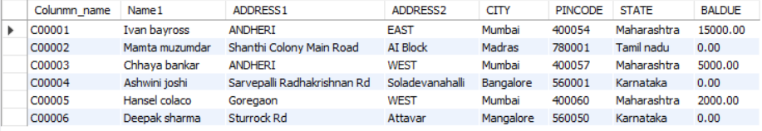

**CLIENT1**

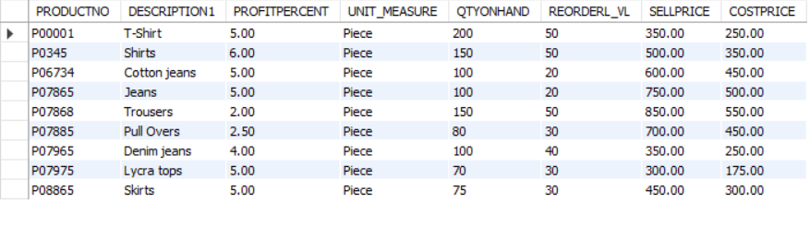

**PRODUCT_Master**

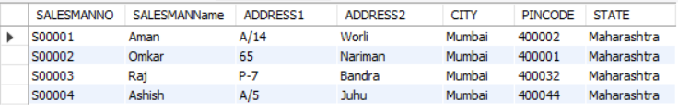

**SALESMAN_Master**

**3. Exercise on retrieving records from a table**

a. Find out the names of all the clients.

**Code:**

use lab_work;

select Name1 from CLIENT1;

**Output:**

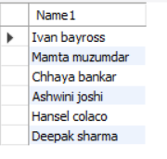

b. Retrieve the entire contents of the Client_Master table

**Code:**

use lab_work;

select * from CLIENT1 ;

**Output:**

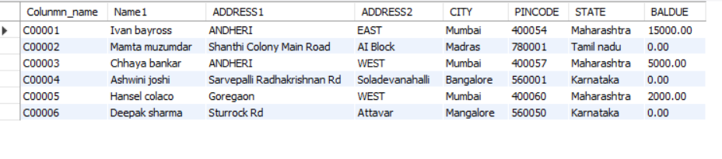

c. Retrieve the list of names, city and the state of all the clients.

**Code:**

use lab_work;

select Name1,CITY,STATE from CLIENT1;

**Output:**

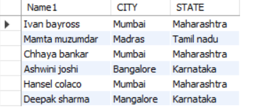

d. List the various products available from the Product_Master table.

**Code:**

use lab_work;

select DESCRIPTION1 from PRODUCT_Master;

**Output:**

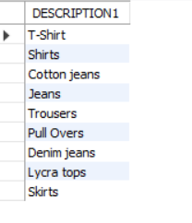

e. List all the clients who are located in Mumbai.

**Code:**

use lab_work;

select * from CLIENT1 where CITY = 'Mumbai';

**Output:**

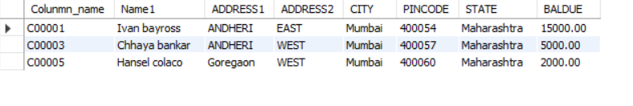

**4. Exercise on updating records in a table**

a. Change the city of ClientNo ‘C00005’ to ‘Bangalore’

**Code:**

use lab_work;

update CLIENT1 set CITY = 'Banglore' where Colunmn_name = 'C00005';

**Output:**

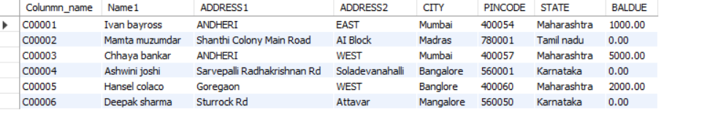

b. Change the BalDue of ClientNo ‘C00001’ to Rs.1000.

**Code:**

use lab_work;

update CLIENT1 set BALDUE = 1000 where Colunmn_name = 'C00001';

**Output:**

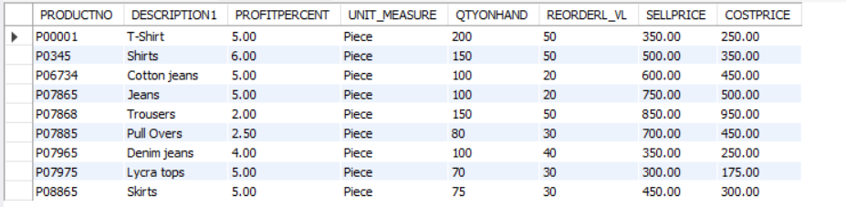

c. Change the city of the salesman to Pune.

**Code:**

use lab_work;

update SALESMAN_Master set CITY = 'Pune' ;

**Output:**

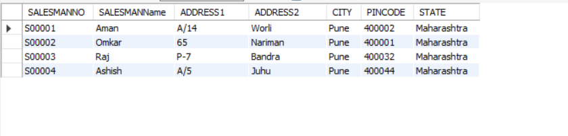

**5. Exercise on deleting records in a table**

a. Delete all products from Product_Master where the quantity on hand is equal to 100

**Code:**

use lab_work;

DELETE FROM PRODUCT_Master where QTYONHAND =100;

**Output:**

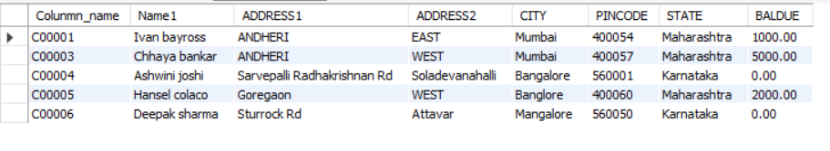

b. Delete from Client1 where the column state holds the value ‘Tamil Nadu’

**Code:**

use lab_work;

DELETE FROM CLIENT1 where STATE ='Tamil nadu';

**Output:**



**6. Exercise on altering the table structure**

a. Add a column called ‘Telephone’ of data type integer to the Client_Master table

**Code:**

use lab_work;

alter Table CLIENT1 Add telephone int(10);

**Output:**

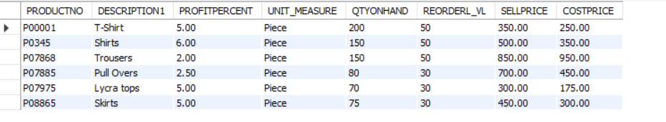

b. Change the size off SellPrice column in Product _Master to 10, 2.

**Code:**

use lab_work;

alter Table PRODUCT_Master Modify SELLPRICE decimaL (10,2);

**7. Exercise on deleting the table structure along with the data**

a. Destroy the table Client1 along with its data.

**Code:**

use lab_work;

DROP TABLE CLIENT1;

**8. Exercise on renaming the table**

a. Change the name of the Salesman_Master to sman_mast

**Code:**

use lab_work;

Alter Table SALESMAN_Master Rename to sman_mast;

**EXPERIMENT-2**

**Title:** To understand and apply the concept of Constraints.

**Objective:** To understand the concept of data constraints that is enforced on data being stored in the table. Focus on Primary Key and the Foreign Key.

**1. Create the following table.**

**Table name:** CLIENT_MASTER_1

**Code:**

use lab_work;

create table CLIENT_MASTER_1 (

CLIENTNO Varchar (6) primary key check(CLIENTNO like '%c'),

NAME1 Varchar (20) not null,

ADDRESS1 Varchar (30),

ADDRESS2 Varchar (30),

CITY Varchar (15),

PINCODE Integer (8),

STATE Varchar (15),

BALDUE Decimal (10,2)

);

**Table Name:** PRODUCT_MASTER_1

**Code:**

use lab_work;

CREATE TABLE PRODUCT_MASTER_1(

PRODUCTNO Varchar (6) Primary Key check( PRODUCTNO like '%p'),

DESCRIPTIONS Varchar (15) Not Null,

PROFITPERCENT Decimal (4,2) Not Null,

UNIT_MEASURE Varchar (10) Not Null,

QTYONHAND Integer (8) Not Null,

REORDERL_VL Integer (8) Not Null,

SELLPRICE Decimal (8,2) Not Null,

COSTPRICE Decimal (8,2) Not Null

);

**Table Name:** SALESMAN_MASTER _1

**Code:**

use lab_work;

CREATE TABLE SALESMAN_MASTER_1(

SALESMANNO Varchar (6) Primary Key check(SALESMANNO like '%s') ,

SALESMANNAME Varchar (20) Not Null,

ADDRESS1 Varchar (30) Not Null,

ADDRESS2 Varchar (30),

CITY Varchar (20),

PINCODE Integer (8),

STATE Varchar (20),

SALAMT Real (8,2) Not Null check(SALAMT!=0),

TGTTOGET Decimal (6,2) Not Null check(TGTTOGET!=0),

YTDSALES Double (6,2) Not Null,

REMARKS Varchar (60)

);

**2. Reinsert the data in these tables.**

**Table name:** CLIENT_MASTER_1

**Code:**

use lab_work;

INSERT INTO CLIENT_MASTER_1

VALUES('c00001', 'Ivan bayross','ANDHERI ','EAST', 'Mumbai', 400054, 'Maharashtra', 15000),

('c00002', 'Mamta muzumdar', 'Shanthi Colony Main Road','AI Block','Madras', 780001, 'Tamil nadu', 0),

('c00003', 'Chhaya bankar','ANDHERI','WEST', 'Mumbai', 400057 ,'Maharashtra' ,5000),

('c00004', 'Ashwini joshi', 'Sarvepalli Radhakrishnan Rd','Soladevanahalli', 'Bangalore', 560001, 'Karnataka', 0);

**Table Name:** PRODUCT_MASTER_1

**Code:**

use lab_work;

INSERT INTO PRODUCT_MASTER_1

VALUES('P00001', 'T-Shirt', 5 , 200,50, 350, 250,56),

('P0345', 'Shirts', 6, 150 ,50 ,500, 350,53),

('P06734' ,'Cotton jeans' ,5 ,100 ,20 ,600,450,54),

('P08865' ,'Skirts ',5 ,75 ,30 ,450 ,300,64);

**Table Name:** SALESMAN_MASTER _1

**Code:**

use lab_work;

INSERT INTO SALESMAN_MASTER_1

VALUES( 's00001' ,'Aman' ,'A/14','Worli','Mumbai',400002,'Maharashtra',56.0,85.5,556.0,'Na'),

('s00002', 'Omkar','65','Nariman', 'Mumbai', 400001, 'Maharashtra',78.0,44.8,564.0,'NA'),

('s00003' ,'Raj' ,'P-7', 'Bandra','Mumbai',400032 ,'Maharashtra',75.0,98.0,435.5,'Na'),

('s00004' ,'Ashish' ,'A/5','Juhu','Mumbai',400044 ,'Maharashtra',74.5,55.2,554.3,'Na');

**3. Display the contents of each table**

**Code:**

use lab_work;

select * from CLIENT_MASTER_1 ;

select * from PRODUCT_MASTER_1;

select * from SALESMAN_MASTER_1;

**Output:**

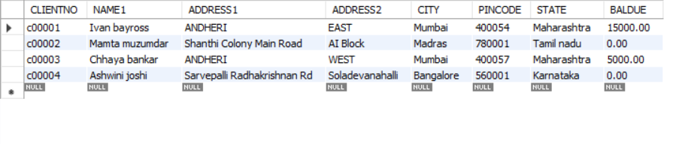

**CLIENT_MASTER_1**

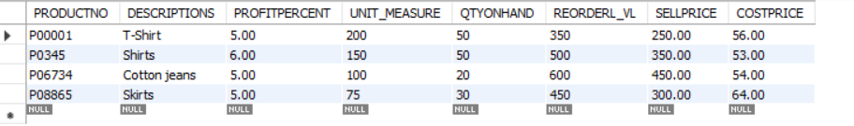

**PRODUCT_MASTER_1**

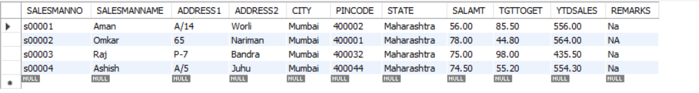

**SALESMAN_MASTER_1**

**4. Create table AUTHOR = {Author_ID , Lastname, Firstname, Email, City, Country}**

**Code:**

use lab_work;

CREATE TABLE AUTHOR

(

Author_ID varchar(5) primary key,

Lastname varchar(15),

Firstname varchar(15),

Email varchar(40),

City varchar(15),

Country varchar(15)

);

**5. Create Table BOOK={ Book_ID, Book_Title, Copies}**

**Code:**

use lab_work;

CREATE TABLE BOOK

(

Book_ID varchar(5) primary key check(Book_ID like 'B%'),

Book_Title varchar(30) not null,

Copies int check(copies >2)

);

**6. Create table AUTHOR_LIST = {Author_ID , Book_ID , Role}**

**Code:**

use lab_work;

CREATE TABLE AUTHOR_LIST(

Author_ID varchar(5) references AUTHOR(Author_ID),

Book_ID varchar(5) references BOOK(Book_ID),

Roles varchar(15),

primary key(Author_ID,Book_ID)

);

**7. Add four records in each tables AUTHOR, BOOK, Author_LIST.**

Table Name: AUTHOR

**Code:**

use lab_work;

INSERT INTO AUTHOR

VALUES ('A0001','Khan','Haseen','haseen@gmail.com','Dehradun','India'),

('A0002','kumar','Kishore', 'kishore@gmail.com','Delhi','India'),

('A0003','Pant', 'Gaurav', 'gaurav@gmail.com', 'Mumbai','India'),

('A0004', 'Katariya', 'Pal', 'Pal@gmail.com', 'Goa', 'India');

Table Name: BOOK

**Code:**

use lab_work;

INSERT INTO BOOK

VALUES ( 'B0001', 'xyz', 5),

('B0002', 'abc', 8),

('B0003', 'def',9),

('B0004','jkl',6);

Table Name: AUTHOR_LIST

**Code:**

use lab_work;

INSERT INTO AUTHOR_LIST

VALUES ('A0001','B0001', 'xyz'),

('A0002','B0002', 'abc'),

('A0003','B0003', 'def'),

('A0004','B0004', 'jkl');

**8. Alter structure of table AUTHOR_LIST add the field Publisher data type of 30 Character.**

**Code:**

use lab_work;

alter Table AUTHOR_LIST Add Publisher varchar(30);

**EXPERIMENT-3**

**Title:** To understand and use SQL Sub-Query

**Objective:** To understand the use of sql subquery.

**1. Create the following table.**

(a) Supplier-(scode,sname,scity,turnover)

**Code:**

use lab_work;

create table Supplier (

Scode varchar(10) primary key,

Sname varchar(50),

Scity varchar(20),

Turnover int

);

(b) Part-(pcode,weigh,color,cost,sellingprice)

**Code:**

use lab_work;

create table Part(

Pcode varchar(10) primary key,

Weigh varchar(20),

Color varchar(30),

Cost decimal(8,2),

Sellingprice decimal (8,2)

);

(c) Supplier_Part-(scode,pcode,qty)

**Code:**

use lab_work;

create table Supplier_Part (

Scode varchar(10) references Supplier(Scode),

Pcode varchar(10) references Part(Pcode),

Qty int,

primary key(Scode,Pcode)

);

**2. Populate the table**

(a) Supplier

**Code:**

use lab_work;

INSERT INTO Supplier

VALUES ('A0001','Haseen', 'Dehradun',50000),

('A0002','Kishore','Delhi',1500000),

('A0003','Gaurav','Mumbai', 200000),

('A0004','Rachit', 'Mumbai',5400000),

('A0005', 'Ritvik', 'Chennai',800000),

('A0006','Akshay', 'Mumbai', 7900000),

('A0007','Ajay', 'Delhi' , 90000),

('A0008','Pal', 'Mumbai',5500000);

(b) Part

**Code:**

use lab_work;

INSERT INTO Part

VALUES ('P0001','26','Black','100','120'),

('P0002','27','White','80','150'),

('P0003','37','Red','75','130'),

('P0004','40','Blue','70','100'),

('P0005', '28','Green', '20', '120'),

('P0006', '32', 'Yellow','30','85'),

('P0007', '34', 'Orange', '40','78'),

('P0008', '29', 'Grey', '45', '200');

(c) Supplier_part

**Code:**

use lab_work;

INSERT INTO Supplier_Part

VALUES ('A0001','P0001',500),

('A0002','P0002',1000),

('A0003','P0003',200),

('A0004','P0004',250),

('A0005','P0005',400),

('A0006','P0006',350),

('A0007','P0007',850),

('A0008','P0008',650);

**Output**

**Code:**

use lab_work;

select * from Supplier;

select * from Part;

select * from Supplier_Part;

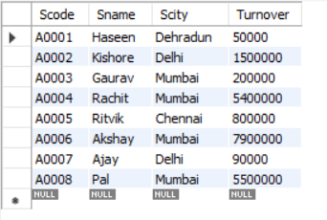

**Supplier**

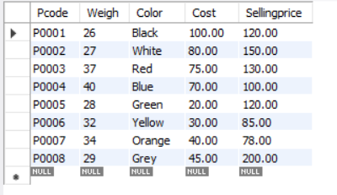

**Part**

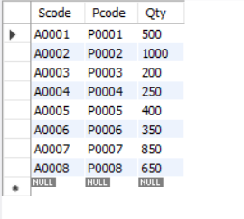

**Supplier_part**

**3. Write appropriate SQL Statement for the following:**

1. Get the supplier number and part number in ascending order of supplier number

**Code:**

use lab_work;

select Scode, Pcode from supplier_part order by Scode;

**Output:**

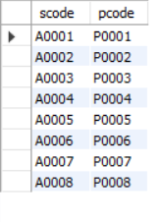

2. Get the details of supplier who operate from Bombay with turnover 50.

**Code:**

use lab_work;

select * from supplier where Scity = 'Mumbai' and Turnover='200000';

**Output:**

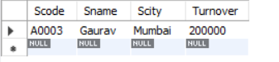

3. Get the total number of supplier.

**Code:**

use lab_work;

select count(sname) from supplier;

**Output:**



4. Get the part number weighing between 25 and 35.

**Code:**

use lab_work;

select Pcode from part where Weigh between 25 and 35;

**Output:**

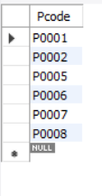

5. Get the supplier number whose turnover is null.

**Code:**

use lab_work;

select Scode from supplier where Turnover='null';

**Output:**

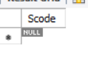

6. Get the part number that cost 20, 30 or 40 rupees.

**Code:**

use lab_work;

select pcode from part where cost in (20,30,40);

**Output:**

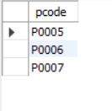

7. Get the total quantity of part 2 that is supplied.

**Code:**

use lab_work;

select Qty from supplier_part where Pcode='P0002';

**Output:**

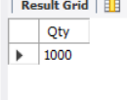

8. Get the name of supplier who supply part 2

**Code:**

use lab_work;

select sname from supplier where scode =

(select scode from supplier_part where pcode='P0002');

**Output:**

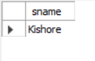

9. Get the part number whose cost is greater than the average cost.

**Code:**

use lab_work;

select pcode from part where

cost > (select avg(cost) from part);

**output:**

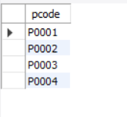

10. Get the supplier number and turnover in descending order of turnover.

**Code:**

use lab_work;

select Scode, Turnover from supplier order by Turnover desc;

**Output:**

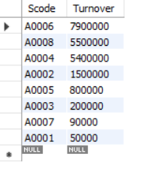

**EXPERIMENT-4**

**Title:** Use of Inbuilt functions and relational algebra operation.

**Objective:** To understand the use of inbuilt function and relational algebra with sql query.

**1. Create the following two tables**

**Table name:** EMP

**Code:**

use lab_work;

CREATE TABLE EMP (

EMPNO int,

ENAME varchar(30),

JOB varchar(30),

MGR varchar(30) ,

HIREDATE date ,

SAL int,

COMM varchar(30),

DEPTNO int REFERENCES DEPT ( DEPTNO)

);

**Table name:** DEPT

**Code:**

use lab_work;

CREATE TABLE DEPT (

DEPTNO int primary key,

DNAME varchar(30),

LOC varchar(30)

);

**2. Reinsert the data in these tables.**

**Table name:** EMP

**Code:**

use lab_work;

INSERT INTO EMP

VALUES ('7369', 'SMITH' ,'CLERK', '7902', '1980-12-17','500', '800','20'),

('7499' ,'ALLEN' ,'SALESMAN' ,'7698' ,'1981-02-20' ,'1600' ,'300','30'),

('7521', 'WARD', 'SALESMAN', '7698', '1981-02-22', '1250', '500', '30'),

('7566' ,'JONES' ,'MANAGER' ,'7839' ,'1981-04-02' ,'2975' ,'','20'),

('7654', 'MARTIN', 'SALESMAN', '7698', '1981-09-28', '1250', '1400', '30'),

('7698' ,'BLAKE' ,'MANAGER' ,'7839' ,'1981-05-01' ,'2850' ,'','30'),

('7782', 'CLARK', 'MANAGER' ,'7839', '1981-06-09', '2450','' ,'10'),

('7788', 'SCOTT', 'ANALYST', '7566', '1982-12-09', '3000', '','20'),

( '7839', 'KING', 'PRESIDENT', '','1981-11-17', '5000','','10'),

('7844' ,'TURNER' ,'SALESMAN' ,'7698' ,'1981-09-08' ,'1500' ,'0','30'),

('7876', 'ADAMS', 'CLERK' ,'7788', '1981-01-12', '1100','', '20'),

('7900' ,'JAMES' ,'CLERK' ,'7698' ,'1981-12-03' ,'950' ,'','30'),

('7902', 'FORD', 'ANALYST', '7566', '1981-12-03', '3000','', '20'),

('7934' ,'MILLER' ,'CLERK' ,'7782' ,'1982-01-23' ,'1300','' ,'10');

**Table name:** DEPT

**Code:**

use lab_work;

INSERT INTO DEPT

VALUES ( '10', 'ACCOUNTING', 'NEW YORK'),

('20' ,'RESEARCH' ,'DALLAS'),

('30', 'SALES', 'CHICAGO'),

('40' ,'OPERATIONS' ,'BOSTON');

**3. Display the contents of each table**

**Code:**

use lab_work;

select * from EMP ;

select * from DEPT ;

**Output:**

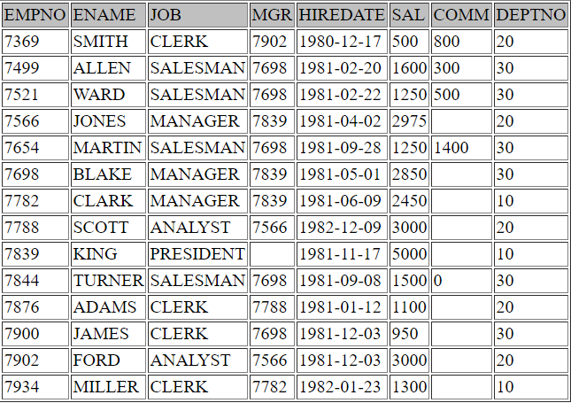

**EMP**

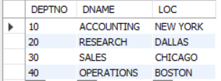

**DEPT**

**4.Write the Nested Queries for the following queries.**

1. List the details of the emps whose Salaries more than the employee BLAKE.

**Code:**

use lab_work;

select * from EMP where SAL>( select SAL from EMP where ENAME='BLAKE');

**Output:**

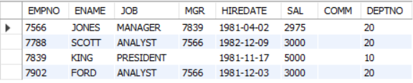

2. List the emps whose Jobs are same as ALLEN.

**Code:**

use lab_work;

select * from EMP where JOB = (select JOB from EMP where ENAME ='ALLEN');

**Output:**

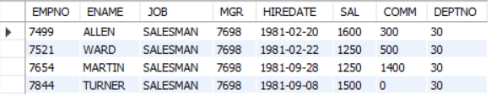

3. List the Emps whose Sal is same as FORD or SMITH in desc order of Names.

**Code:**

use lab_work;

Select * from EMP where SAL in (select SAL from EMP where ( ENAME = 'SMITH' or ENAME = 'FORD' )) order by SAL desc;

**Output:**

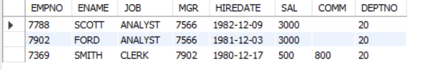

4. List the emps Whose Jobs are same as MILLER or Sal is more than ALLEN.

**Code:**

use lab_work;

select * from EMP where JOB = (select JOB from EMP where ENAME ='MILLER' ) or

SAL>(select SAL from EMP where ENAME = 'ALLEN');

**Output:**

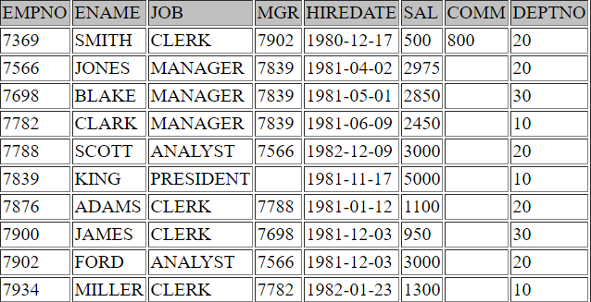

5. Find the highest paid employee of sales department.

**Code:**

use lab_work;

select * from EMP where sal in (select max(SAL) from EMP where DEPTNO=(select DEPTNO from DEPT where DNAME= 'SALES'));

**Output:**



6. List the employees who are senior to most recently hired employee working under king.

**Code:**

use lab_work;

select * from EMP where HIREDATE < (select max(HIREDATE) from EMP where MGR

in (select EMPNO from EMP where ENAME= 'KING')) ;

**Output:**

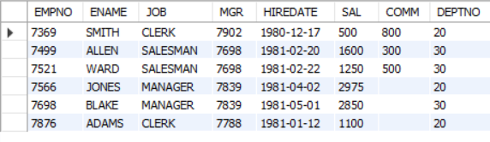

7. List the names of the emps who are getting the highest sal dept wise.

**Code:**

use lab_work;

select ENAME, DEPTNO from EMP where SAL in

(select max(SAL) from EMP group by DEPTNO) ;

**Output:**

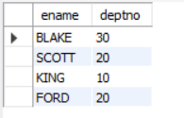

8. List the emps whose sal is equal to the average of max and minimum .

**Code:**

use lab_work;

select * from EMP where SAL =(select (max(SAL)+min(SAL))/2 from EMP);

**Output:**



**No Data Found**

9. List the emps who joined in the company on the same date.

**Code:**

use lab_work;

select * from EMP E where HIREDATE in

(select HIREDATE from EMP where E.EMPNO <> EMPNO);

**Output:**

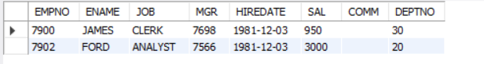

10. Find out the emps who joined in the company before their Managers.

**Code:**

use lab_work;

select * FROM EMP E WHERE HIREDATE < (select HIREDATE FROM EMP WHERE EMPNO = E.MGR);

**Output:**

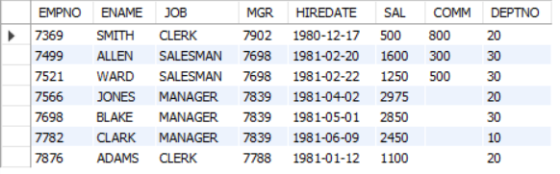

**EXPERIMENT-5**

**Title:** Use of different SQL clauses and join.

**Objective:** To understand the use of group by and having clause and execute the SQL commands using JOIN.

**1. Write the SQL Queries for the following queries**

1. List the Deptno where there are no emps.

**Code:**

use lab_work;

select DEPTNO from DEPT where DEPTNO not in (select DEPTNO from EMP);

**Output:**

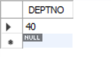

2. List the No.of emp’s and Avg salary within each department for each job.

**Code:**

use lab_work;

select count(*), avg(SAL),DEPTNO,JOB from EMP group by DEPTNO,JOB;

**Output:**

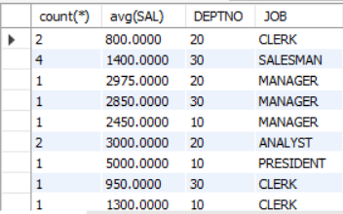

3. Find the maximum average salary drawn for each job except for ‘President’.

**Code:**

use lab_work;

select max(MRAVG) from(select avg(SAL) MRAVG from EMP where JOB!='PRESIDENT' group by JOB)a

**Output:**

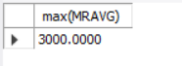

4. List the department details where at least two emps are working.

**Code:**

use lab_work;

select DEPTNO, count(*) from EMP group by DEPTNO having count(*)>=2;

**Output:**

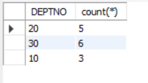

5. List the no. of emps in each department where the no. is more than 3.

**Code:**

use lab_work;

select DEPTNO, count(*) from EMP group by DEPTNO having count(*)>3;

**Output:**

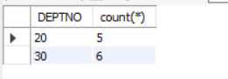

6. List the names of the emps who are getting the highest sal dept wise.

**Code:**

use lab_work;

select ENAME ,DEPTNO from EMP where SAL in ( select max(SAL) from EMP group by DEPTNO);

**Output:**

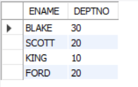

7. List the Deptno and their average salaries for dept with the average salary less than the averages for all departments.

**Code:**

use lab_work;

select avg(SAL), DEPTNO from EMP group by DEPTNO having avg(SAL)<(select avg(SAL) from EMP);

**Output:**

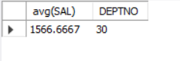

**2. Execute the experiment 4 using sql join.**

**Code:**

use lab_work;

select * from EMP join DEPT on EMP.DEPTNO=DEPT.DEPTNO;

**Output:**

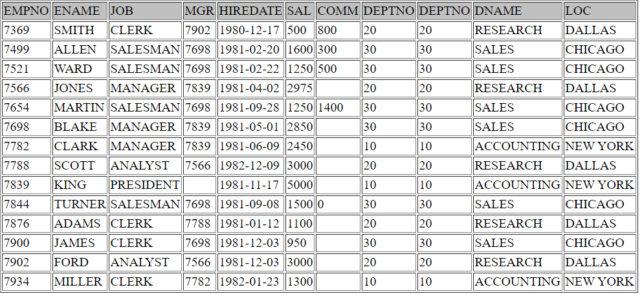

**EXPERIMENT-6**

**Title:**To understand the concepts of Views.

**Objective:** Students will be able to implement the concept of views.

1. Create table of table name: EMPLOYEES

use lab_work;

CREATE TABLE EMPLOYEES (

Employee_id Char (10) primary key,

First_Name Char (30) not null,

Last_Name Char (30) not null,

DOB Date,

Salary int not null ,

Department_id varchar (10)

);

1) Create View of name emp_view and the column would be Employee_id, Last_Name, salary and department_id only.

use lab_work;

CREATE VIEW emp_view AS

SELECT Employee_id,Last_Name,Salary, Department_id

FROM EMPLOYEES ;

2) Insert values into view(remove the NOT NULL constraint and then insert values):

use lab_work;

Alter Table EMPLOYEES modify First_Name varchar(30) null;

Alter Table EMPLOYEES modify Last_Name varchar(30) null;

Alter Table EMPLOYEES modify Salary int null;

use lab_work;

insert into emp_view

values('E01','Khan','100000','D01'),

('E02','Dubey','150000','D02'),

('E03','Pant','90000','D03'),

('E04','Kumar','50000','D04'),

('E05','Tyagi','55000','D05'),

('E06','Kala','890000','D06');

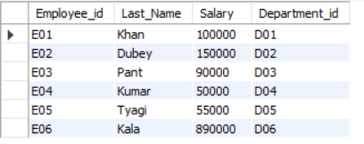

3) Modify, delete and drop operations are performed on view

use lab_work;

Update emp_view set Department_id='D04' where Employee_id='E03';

Update emp_view set Employee_id='E015' where Department_id='D01';

Update emp_view set Department_id='D02' where Employee_id='E05';

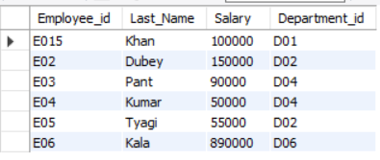

use lab_work;

Delete from emp_view where Salary='890000';

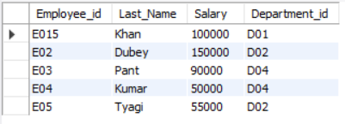

use lab_work;

Drop view emp_view;

4) Creates a view named salary_view. The view shows the employees in department 20 and their annual salary.

use lab_work;

create view Sal_view as select Employee_id,Last_Name ,Salary,Department_id from EMPLOYEES where Department_id='D02';

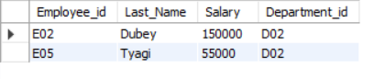

**EXPERIMENT-7**

**Title:** To understand the concepts of Index.

**Objective:** Students will be able to implement the concept of index.

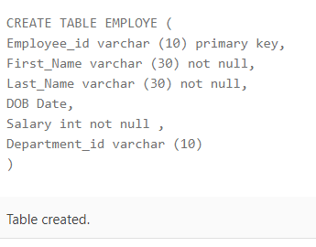

insert into EMPLOYE

values('E01','Haseen','Khan',to_date('29-12-1996','dd-mm-yyyy'),'100000','D01')

insert into EMPLOYE

values('E02' ,'Juhi','Dubey',to_date('17-02-1999','dd-mm-yyyy'),'150000','D02')

insert into EMPLOYE

values('E03','Gaurav','Pant',to_date('30-03-1994','dd-mm-yyyy'),'90000','D03')

insert into EMPLOYE

values('E04' ,'Kishore','Kumar',to_date('14-07-1995','dd-mm-yyyy'),'50000','D04')

insert into EMPLOYE

values('E05' ,'Ajay','Tyagi',to_date('02-09-2000','dd-mm-yyyy'),'55000','D05')

insert into EMPLOYE

values('E06' ,'Ritivk','Kala',to_date('29-03-2000','dd-mm-yyyy'),'89000','D06')

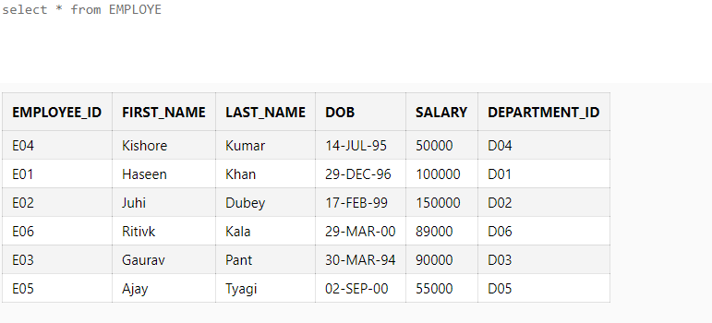

1) Create an index of name employee_idx on EMPLOYEES with column Last_Name, Department_id

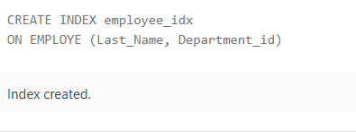

2) Find the ROWID for the above table and create a unique index on employee_id column of the EMPLOYEES.

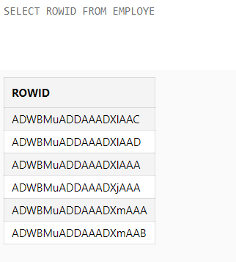

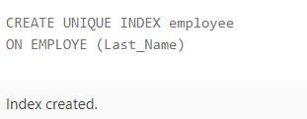

3) Create a reverse index on employee_id column of the EMPLOYEES.

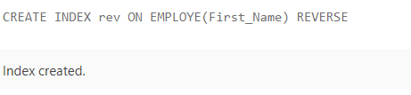

4) Create a unique and composite index on employee_id and check whether there is duplicity of tuples or not.

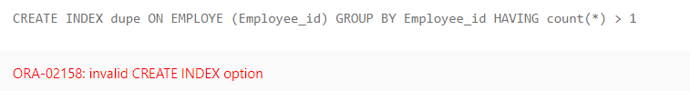

5) Create Function-based indexes defined on the SQL functions UPPER(column_name) or LOWER(column_name) to facilitate case-insensitive searches(on column Last_Name).

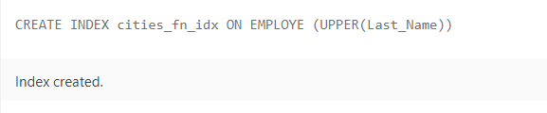

6) Drop the function based index on column Last_Name

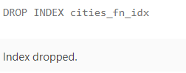

**EXPERIMENT-8**

**Title:** To understand the concepts of Sequence.

**Objective:** Students will be able to implement the concept of sequence.



1) Create a sequence by name EMPID_SEQ starting with value 100 with an interval of 1.

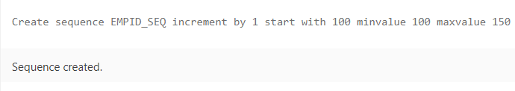

2) Write a SQL command for finding the current and the next status of EMPID_SEQ.

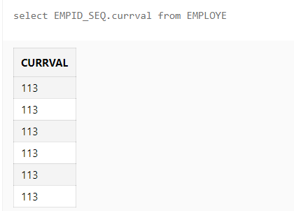

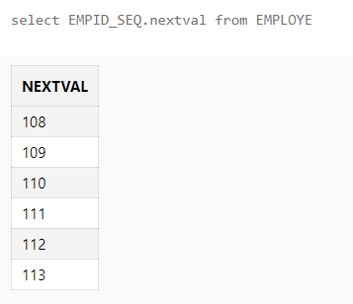

3) Change the Cache value of the sequence EMPID_SEQ to 20 and maxvalue to 1000.

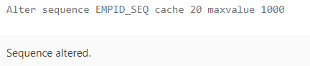

4) Insert values in employees table using sequences for employee_id column.

insert into EMPLOYE

values(EMPID_SEQ.nextval ,'Haseen','Khan',to_date('29-12-1996','dd-mm-yyyy'),'100000','D01')

insert into EMPLOYE

values(EMPID_SEQ.nextval ,'Juhi','Dubey',to_date('17-02-1999','dd-mm-yyyy'),'150000','D02')

insert into EMPLOYE

values(EMPID_SEQ.nextval ,'Gaurav','Pant',to_date('30-03-1994','dd-mm-yyyy'),'90000','D03')

insert into EMPLOYE

values(EMPID_SEQ.nextval ,'Kishore','Kumar',to_date('14-07-1995','dd-mm-yyyy'),'50000','D04')

insert into EMPLOYE

values(EMPID_SEQ.nextval ,'Ajay','Tyagi',to_date('02-09-2000','dd-mm-yyyy'),'55000','D05')

insert into EMPLOYE

values(EMPID_SEQ.nextval ,'Ritivk','Kala',to_date('29-03-2000','dd-mm-yyyy'),'89000','D06')

5) Drop sequence EMPID_SEQ.

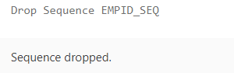

6) Create a sequence called REVERSE to generate numbers in the descending order from 10000 to 1000 with a decrement of 5.

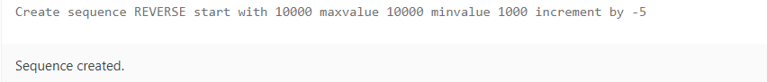

**EXPERIMENT-9**

**Title:**To understand the concepts of PL/SQL programming.

**Objective:** Students will be able to implement the basic concepts of Pl/SQL.

1) Write a PL/SQL code to accept the value of A, B & C display which is greater.

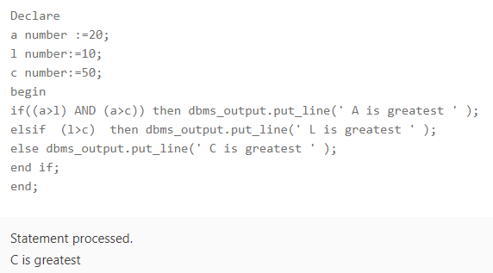

2) Using PL/SQL Statements create a simple loop that display message “Welcome to PL/SQL Programming” 20 times.

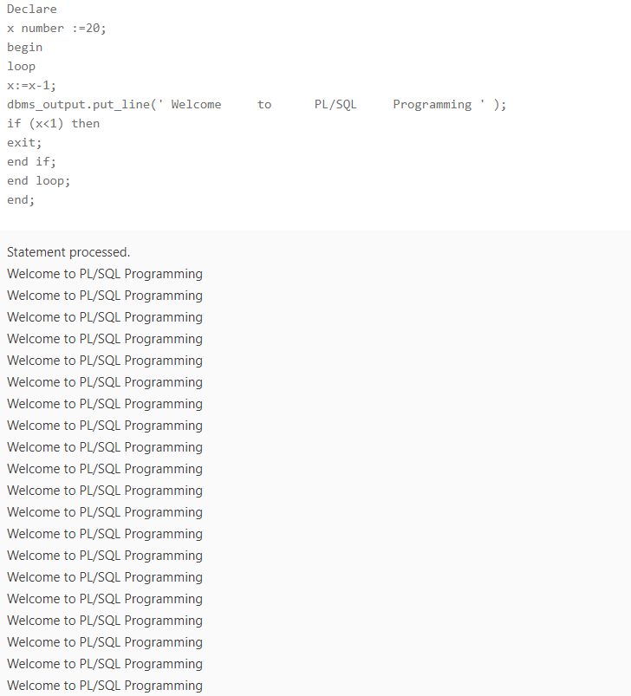

3) Write a PL/SQL code block to find the factorial of a number.

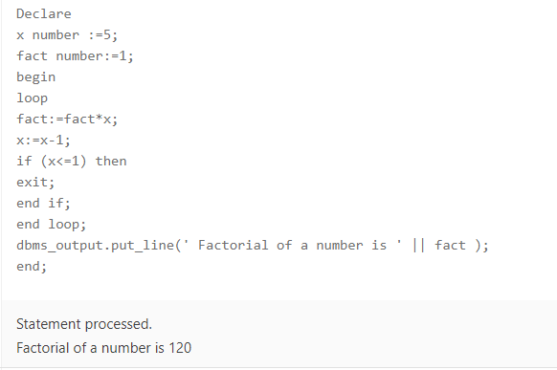

4) Write a PL/SQL program to generate Fibonacci series.

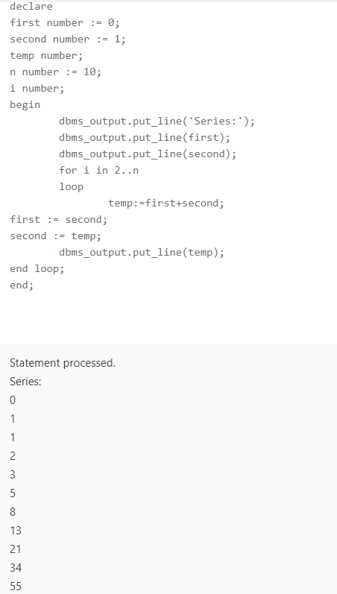

5) Write a PL/SQL code to fund the sum of first N numbers

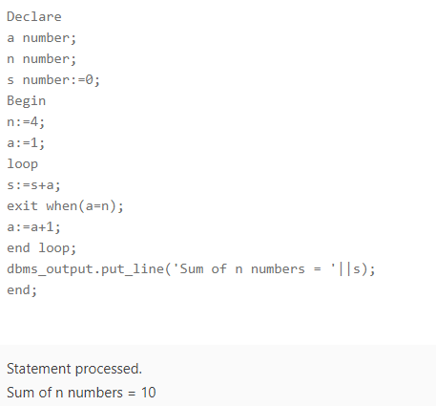

. **EXPERIMENT-10**

**Title:**To understand the concepts of function and procedure in PL/SQL.

**Objective:** Students will be able to implement the Pl/SQL programs using function and procedure.

Implement the experiments of lab 9 using functions and procedures

1) Write a PL/SQL code to accept the value of A, B & C display which is greater.

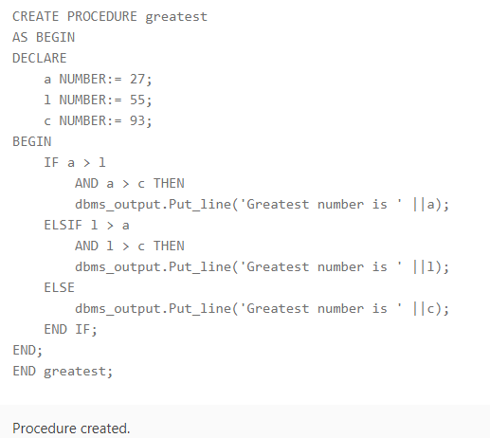

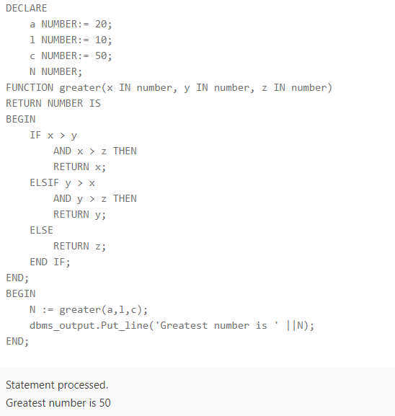

2) Using PL/SQL Statements create a simple loop that display message “Welcome to PL/SQL Programming” 20 times.

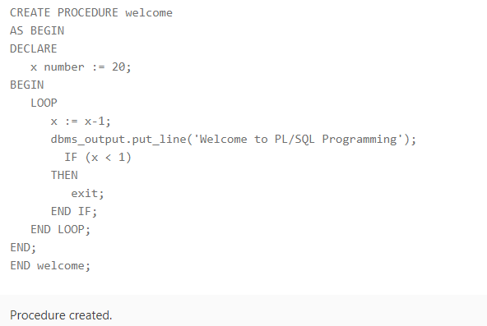

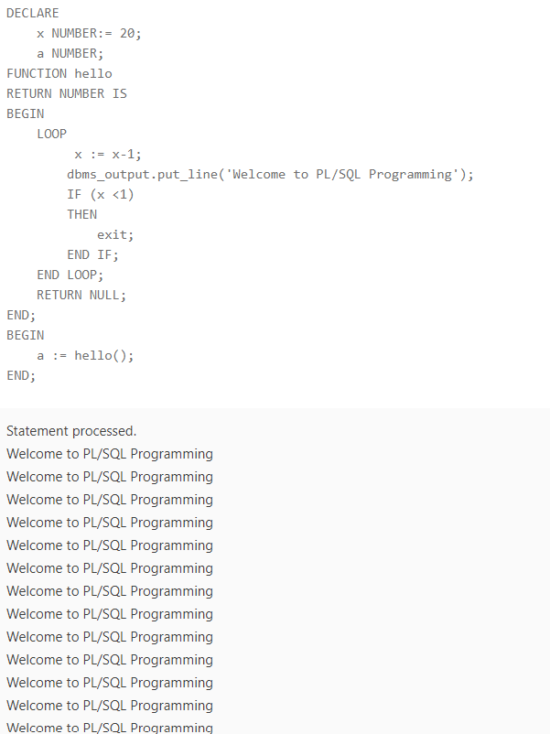

3) Write a PL/SQL code block to find the factorial of a number.

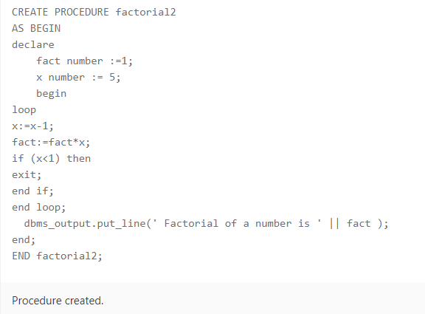

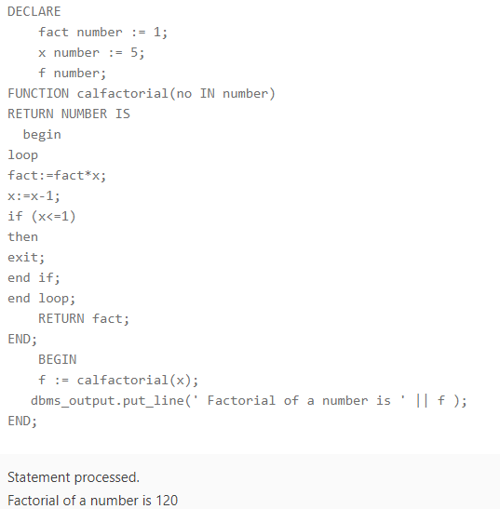

4) Write a PL/SQL program to generate Fibonacci series.

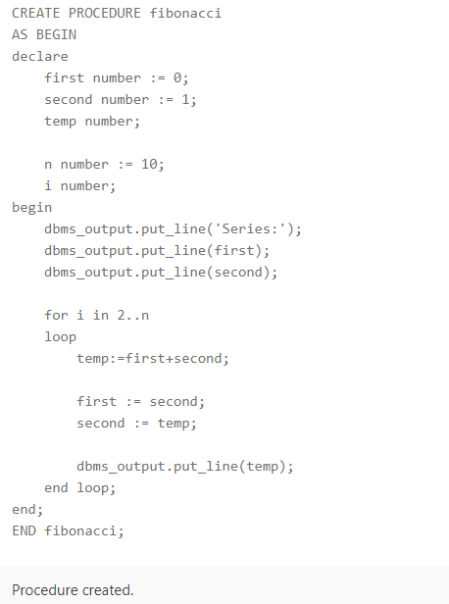

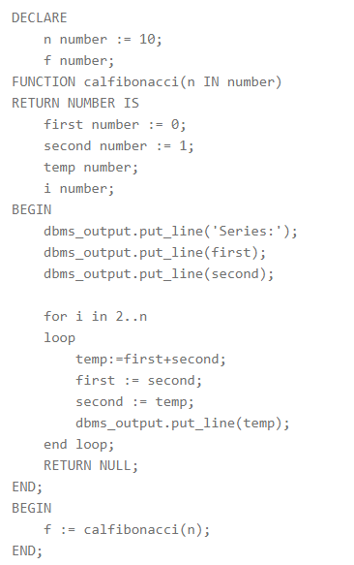

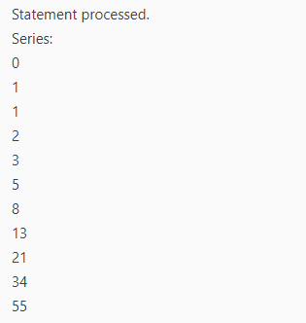

5) Write a PL/SQL code to fund the sum of first N numbers

